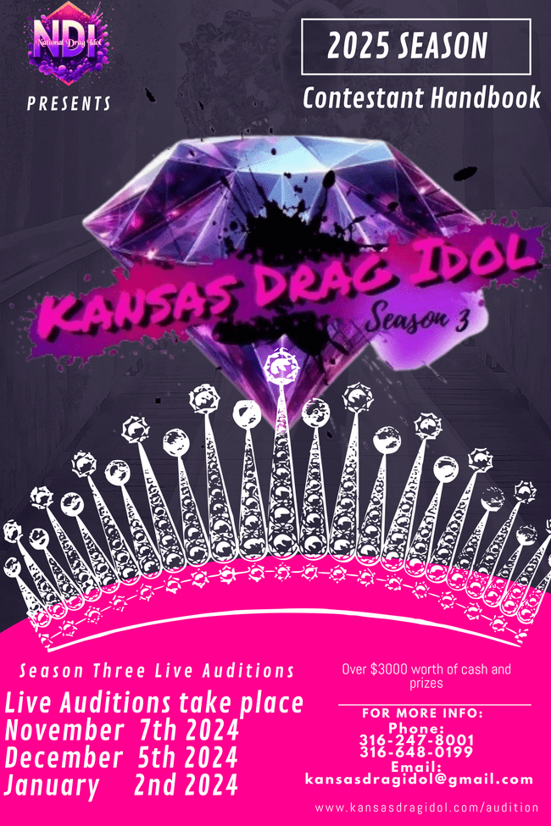

**Table of contents**

* **Page 1 …………………………………….. Welcome Letter**
* **Page 2 ….......................................................Introduction to Kansas Drag Idol**
* **Page 3.…...............................................................Points Scoring**
* **Page 4 ...................................................................Judging Criteria**
* **Page 5....................................................................Show Themes**
* **Page 6....................................................................Rules and Signature**

Dear Contestant,

We are absolutely thrilled to welcome you to the Kansas Drag Idol family! We are honored that you are interested in joining our vibrant community of talented queens, kings, and everything in between who are part of the national drag idol family.

As your promoters we are excited to have you on board and look forward to seeing the amazing things you will bring to the table. Your passion for drag and your unique style will undoubtedly add to the richness and diversity of our community.

We believe that drag is not just about glamour and entertainment, but also about self-expression, empowerment, and inclusivity. As a part of Kansas Drag Idol, we strive to create a safe and supportive environment where all queens, kings, and everything in between can thrive and be their authentic selves.

As you embark on this journey with us, we want you to know that you are not alone. You will be surrounded by a community of Performers who are dedicated to helping each other grow and succeed. We will be here to support you every step of the way, from sharing tips and advice to celebrating your successes.

We are excited to see the incredible things you will accomplish as part of Kansas Drag Idol. Your talent, creativity, and charisma will undoubtedly inspire and uplift others, and we are honored to be a part of your journey.

Once again, welcome to the Kansas Drag Idol family! We can't wait to see what the future holds for you.

With love and support,

Taquella Roze, Imani KO. Kotour, Janeeda Cox, Juicee the Jester, and Julia K. Johnson

Pg1

**Introduction**

Thank you for your interest in Kansas Drag Idol, an exciting drag competition designed to push your artistry to the next level! This contest will start on Thursday, March 6th, 2025, at 8:00 pm at Vorshay's, located at 417 E. Douglas Ave, Wichita, KS 67202. Contestants must arrive no later than 6:00 pm. If you are late, points will be deducted. Contestants must be 21 years or older by the date of the first show (Thursday, March 6th, 2025).

We are a family, and we are excited to see what you can bring to this competition. We strive to put together a show unlike any other. We are only casting the top 8 competitors. If you are not chosen, you will be a backup and may still compete. Each month, you will compete for a chance to win a $75 cash prize. At the end of the competition, the winner will receive a cash prize of $1,150 ($575 at the crowning ceremony and $575 at the step-down ceremony), a sash, custom scepter, custom jewelry (up to $175), a custom wig, seamstress voucher , a photo shoot, and an embellished crown.

The way to enter is by auditioning online at kansasdragidol.com under "auditions" and pay the $25 entry fee. You will be asked to attend the live auditions as well, so be prepared. You must submit a full-body photo of yourself in your drag for promotional use. This can be uploaded at kansasdragidol.com under auditions. This is a six-month long competition. By signing up for this competition, you agree to fulfilling this obligation.

The winner will also be cast with six paid bookings at $75 per booking and required to host a charity show in October 2025. Shows prizes are estimated around $3,000 but could be worth even more. Each night of the competition, there will be a winner who will receive a $75 cash prize and possibly more prizes from sponsors as well.

pg 2

**Points Scoring**

Now you may be asking what does the competition consist of? Each show you will be required to Compete with a predetermined runway (week one is show us who you are), a themed number (week one is the talent show) and a number of your choice this category will NOT be judged. You will be judged on these criteria

|  |  |  |
| --- | --- | --- |
| Your ability to follow the theme possible | 10 | points |
| Your creativity possible | 10 | points |
| How well you model possible | 10 | points |
| Fit of outfit possible  Q and A possible    overall possible 60 points    theme number | 10  20 | Points  Points |
| Your ability to follow the theme possible | 10 | points |
| Your creativity possible | 10 | points |
| Stage presence possible | 10 | points |
| Entertainment value possible | 10 | points |
| Lip sync/singing ability possible | 10 | points |
| Over all look possible | 10 | points |
| Over all performance possible    Promoting is important | 10 | Points |
| Promoting | 20 | Points |

over all possible 90 points

a combined total of possible 150 points

pg 3

**Judging Criteria**

Below are the themes for the duration of the competition. Creative and talent are two different themes

Talent: The point of talent is to be able to show your individuality and understanding of the theme below are examples of what will be expected of you for talent. REMEMBER CREATIVITY IS KEY!!!

* Ability to follow theme
* creativity
* Stage Presence
* Entertainment value
* Lip sync/singing Ability
* Overall Performance

Creative: creative theme is to show us who you are, nothing is off limits. Please read rules listed for any stipulations. Round one in fashion is show us who you are. This is your time to show us your drag and who you are. Things we are looking for

* Ability to follow theme
* Seamlessness/Fitting to your body
* Overall Creativity
* Ability to model
* Question & Answer
  + In Q&A we are looking for your ability to answer on stage question with seamlessness and originality, but yet remaining true to who you are.

None judged numbers you are allowed to do whatever you want and collect tips. Feel free to stick to the theme or bring out a completely different Number this is completely up to you but do please keep this crowd friendly nudity is not allowed and showing any explicit content is to be kept to a minimum.

Save Me Number: In this category two contestants will be selected to lip sync Based off of a preselected song of choice. You will ONLY need to perform this number if you are asked to. Most commonly when you end up in the bottom two for the night. BRING YOUR BEST. Show us you want to stay and why we should select you to continue on to the next round. music can only be 2 minutes no longer, if your music is longer your music will simply not be played.

You are also able to earn or LOSE points based on promotional's. This means you must share every poster you are put on twice a week. As this is a competition you want to make sure you bring as many people as you can or at least share the poster given to you each month. The total point value is 20. this will allow you to stay ahead or may put you in the bottom. !!!THIS IS STRICTLY GRADED ON PARTICIPATION!!!

Pg 4

Monthly Themes

**Month 1 Theme:**

* Creative: Show us who you are

Bring your Best Drag show us who you are and what you are all about.

* Talent: Talent show

Show us your best talent what you are good at and what sets you apart

**Month 2 Theme:**

* Creative: Camp Kitch

Camp Drag has arrived! It's a fashion spectacle of sparkling disasters, with clothes so tight they scream for mercy, wigs with their own gravity, and accessories that defy reality!

* Talent: Camp Kitch

Show us your campy side! Make us laugh with this campy comedy talent. Think outside the box be brave and bring the laughs!

**Month 3 Theme:**

* Creative: Paint the town Red

Make it red! We want to see your best in red! From clothing to shoes to hair and jewelry we want red!

* Talent: Paint the town!

A color will be drawn at random the month before for your talent. You must perform a number that matches this color and have a costume to match

**Month 4 theme:**

* Creative: Dark side of Disney Fashion:

Show us a Disney Villain or your favorite Disney characters dark side from any of the Disney franchise. Be very creative and set your self apart.

* Talent: Dark side of Disney talent: show us a Disney Villain or your favorite Disney characters dark side from any of the Disney franchise. Be very creative and set your self apart.

**Month 5 theme:**

* Creative: Journey through the jungle

you must represent an animal all night that is drawn at random the month before. You can take it literal or make it your own, but we want to look at you and know what animal you are!

* Talent: Journey through the jungle

you must take your animal and incorporate it with your performance we want to see you in a different costume and ready to entertain us with this challenge!

**Month 6 theme Grand Finale:**

* Creative: High Drag Fashion

This is the Grand finale we want to see the best drag you own show us why you deserve to win and why you are Kansas Next Drag Idol

Everyone is required to come back and must also show us this creative fashion

* Talent: High Drag Talent

This is your time to shine show us all you got! Leave it on the stage. There can only be one winner

(for people who are not competing you must prepare the number you were eliminated on and one other number to this night)

Pg5

**Rules**

Each show will feature the elimination of at least one performer. The bottom two contestants will then perform their "Save Me" number, a selection of their choice. Each show will also crown a winner who will receive a special prize. Participants retain their tips from there unjudged number only. Soliciting tips during the "Save Me" performance will result in immediate disqualification. We reserve the right to reinstate any contestant at our discretion.

In the event a contestant withdraws from the competition, the following month's eliminated contestant will take their place. Pre-competition withdrawals will see a backup contestant stepping in. Fire, water, and excessive glitter are prohibited. The winner must participate in next season shows, with final decisions resting with the hosts of Kansas Drag Idol. Rules are subject to change at their discretion. In light of recent events within our drag community, Kansas Drag Idol enforces strict guidelines: Non-POC performers are prohibited from using racially insensitive language. Hate speech, including racial, transphobic, and ableist slurs, whether backstage or on stage, is strictly forbidden. Violation of these rules will lead to immediate removal from the stage, with music stopped and performers escorted out. Offenders are permanently barred from future participation. In case of rule violations, a genuine apology is expected. Fighting, theft, or disruptive behavior will result in immediate ejection. Drug and excessive alcohol use on competition nights are strictly prohibited as participants are representatives of our values of safety and professionalism. All contestants must arrive at least two hours before roll call, in face. Venue access is permitted up to two hours prior to the show. Personal dressers are generally not allowed, except for cases of disability, where assistance will be provided as needed. Contestants are encouraged to seek assistance when necessary. Unauthorized individuals in the backstage area will result in deduction of contestant points. All contestants are required to clean up after themselves thoroughly before leaving. Dancers are permitted in the backstage area up to 20 minutes before their performance; earlier access is not allowed. Music submissions must be received one week before the live show, in full audio tracks with clear labeling: "yournameFashion," "yournameTalent," "yournameUnjudged," "yournameSaveme." Set-up and tear-down time are limited to a total of four minutes, with prior notice required for any additional needs. Performances must not exceed six minutes; submissions exceeding this limit will not be played. All talent tips will be donated to our charity sponsor. Tips collected during non-judged performances go directly to the contestant. No tips are accepted during the "Save Me" song; acceptance of tips during this time results in immediate elimination. Attendance at the finale is mandatory; failure to attend will require repayment of all prizes received, including sponsor and cash prizes, or a $100 fine if no prizes were won. At the finale, eliminated contestants must perform their elimination number to demonstrate personal growth. A small prize package is awarded for this occasion. Set placements at the finale will follow the order of elimination. High drag fashion will be judged, with a unique interpretation of the contestant's finale performance. The winner among eliminated contestants will receive a small prize. Last but not least please keep on theme through out the night. If you do not show up from a night (with out good reasoning and no communication) you are liable for a $100 fine and the previously eliminated contestant will take your placement. So with that being said you are required to show up to EVERY show in face ready to go.

Any questions please message

Kansas Drag Idol on Facebook

email: kansasdragidol@gmail.com

call: 316-247-8001 or 316-648-0199

website: kansasdragidol.com

audition: kansasdragidol.com/audition

By signing this I ____________________________ (legal name) agree to all rules and regulations and understand that i will follow all commitments listed

signed _______________________________ Date ________________

Pg6